**Optimising trigger times for social distancing measures (SDMs)**

M. Woolhouse and B. van Bunnik, University of Edinburgh (04/03/20)

Key conclusions

* Two possible straegies for time-limited SDMs (all-or-nothing and ramping up) are both much less effective in reducing the epidemic peak if they are started too early or too late.
* The ramping up strategy is more robust to uncertainty about the actual impact of SDMs on transmission rate.
* Both strategies are much less effective if the basic reproduction number (R0) is higher or lower than expected (unless it is very low).

Policy Implications

* Identifying the optimal time to introduce SDMs may be extremely difficult in practice. The ‘sweet spot’ is very small.
* In some respects a ramping up strategy is more robust to uncertainties in key parameters than an all-or-nothing strategy.
* Accurate estimates of position on the epidemic curve and of R0 are particularly important for identifying the optimal time to introduce SDMs.

Results

The baseline scenario is as for our first report (29/02/20). This gives peak fraction infected I(t)=0.153 on day 79 and total I=0.797.

We explore deviations from optimal epidemic curves. Optimal is defined as the curve that gives the lowest value for the peak fraction infected at any one time during the course of the epidemic. This is chosen for consistency with the policy objective of flattening the peak.

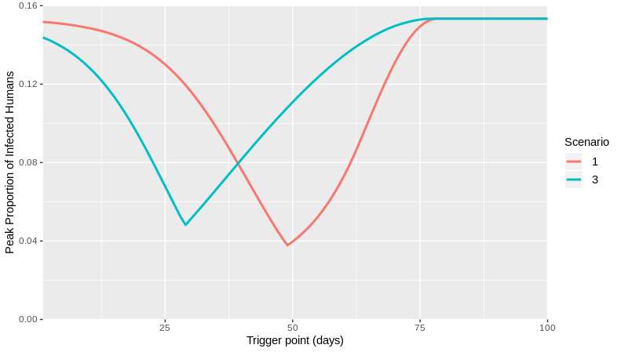

*Figure 1. Impact of sub-optimal trigger day. Peak fraction infected as a function of trigger days before or after the optima for Scenario 1 (all-or-nothing) and Scenario 3 (ramping up). The optimal trigger points occur at day 49 and 29 respectively.*

Figure 1 explores the impact of suboptimal trigger days (with all other parameters unchanged).

For both scenarios there is a steep increase in peak fraction infected if the trigger day is too early or too late.

If SDMs are implemented too soon there is a sharp increase in peak fraction infected. The rate of increase is similar for both scenarios.

If SDMs are implemented too late there is again a sharp increase in peak fraction infected. However, the rate of increase is greater for Scenario 1, making Scenario 3 somewhat more robust to delayed implementation.

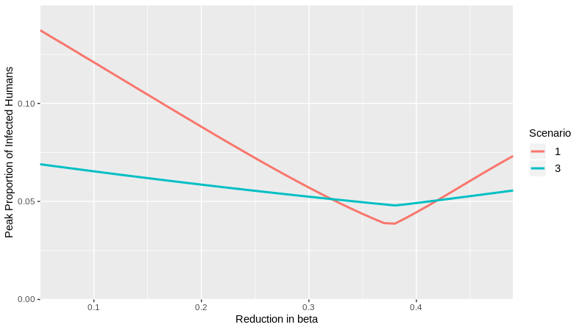

*Figure 2. Impact of inaccurate estimates of the reduction in* β *achieved by SDMs. Peak fraction infected as a function of fractional reduction in* β *for Scenario 1 (all-or-nothing) and Scenario 3 (ramping up). SDMs are triggered on the optimal day given a reduction in* β of 37.5%. *Results are shown for true reduction in* β *less (down to 5%) or more (up to 50%) than expected*.

Figure 2 explores the impact of higher or lower reductions in β than the expected 37.5% (with all other parameters unchanged).

For Scenario 1 there is a steady increase in peak fraction infected if the reduction in β is less than expected. Less expectedly, there is also an increase if it is *more* than expected. This is because the all-or-nothing strategy now becomes too much, too soon.

For Scenario 3 there is much less variation in peak fraction infected. Outside a narrow range of values either side of 37.5% the peak is lower than for Scenario 1.

This suggests that a ramping up strategy is more robust to uncertainty in the reduction in β achieved by SDMs.

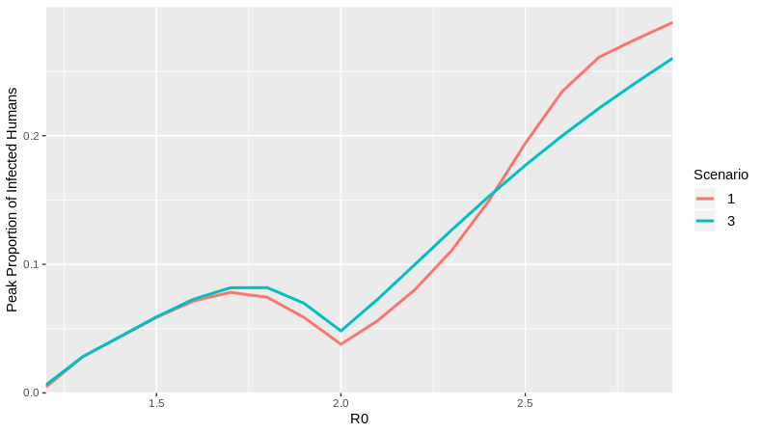

*Figure 3. Impact of inaccurate estimates of R0. Peak fraction infected as a function of R0 for Scenario 1 (all-or-nothing) and Scenario 3 (ramping up). SDMs are triggered on the optimal day given R0=2.* *Results are shown for true R0 lower (down to 1.2) or higher (up to 3)*.

Figure 2 explores the impact of higher or lower reductions in β than the expected 37.5% (with all other parameters unchanged).

For both scenarios the strategy is worse than optimal if R0 is higher or lower than expected, unless R0 is very low (around 1.3). Quite small differences in R0 (±0.25) lead to markedly worse outcomes.

Technical Details

SIR model implemented in R and C++ independently (code to be made available at https://github.com/bvbunnik/COVID-19.git).

Baseline parameter values: R0=2; β = 0.231; doubling time = 6 days; SDM duration = 12 weeks.

We compare 2 SDM strategies. Scenarion 1 refers to an all-or-nothing strategy. The effect of the SDMs is to reduce the per capita transmission rate, β, by 37.5%. Scenario 3 refers to a ramping up strategy for a reduction in β that increases linearly from 0% to 75% (so averaging 37.5% over the 12 weeks).

Given those reductions in β both scenarios are optimised with respect to trigger point. The trigger points correspond to an optimal start day of 49 days for Scenario 1 and 29 days for Scenario 3, corresponding to peak fraction infected of 0.038 and 0.048 respectively.

The trigger point analysis (Figure 1) explores the resulting peak fraction infected for simulations of the two scenarios that differ only in trigger days (versus 49 and 29 days)

The β reduction analysis (Figure 2) explores the resulting peak fraction infected for simulations of the two scenarios that differ only in the fractional reduction in β (versus 0.375).

The R0 analysis (Figure 3) explores the resulting peak fraction infected for simulations of the two scenarios that differ only in R0 (versus 2.0). R0 is altered by adjusting β not γ.

Rationale

SDMs are intended to be time limited. Multiple SDMs are available and can be implemented independently. (Many) SDMs are hugely socially and economically costly.

We have very little knowledge of the likely effect of a given SDM (or combination) on β.

Here, we assume only that costs and effects can be ‘exchanged’ so that by implementing different SDMs at different times we can alter the shape of the β(t)-curve during the period of interest.

We can optimise the trigger point for any combination of the parameters R0, β-reduction and shape of the β(t)-curve. However, in practice there will be considerable uncertainty about the state of the epidemic relative to the trigger point (due to imperfect case identification this has to be estimated indirectly). There is also huge uncertainty about the reduction in β that can be achieved. There may also be uncertainty about R0, especially in the earliest stages of the epidemic.

Caveats

This is a very simple model and is intended to be illustrative, not predictive of an actual COVID-19 epidemic.

We do not take into account time varying compliance with imposed SDMs.

We do not take into account social distancing arising from spontaneous behavioural change and affecting β.

Ongoing work

Explore the impact of combinations of sub-optimal values for day, β-reduction and R0.

It would be worthwhile ascertaining whether the same patterns can be replicated using more detailed models.